Move Steering Block

# Basics

Number of Rotations/Degrees/ Seconds

Brake when finished

Right Motor Port

Left Motor Port

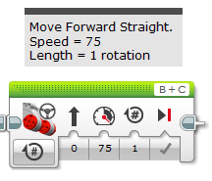

MENU

Speed of Movement

Direction of Movement

# Move Tank – Menu

## Off

This block is used to stop or brake the motors.

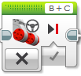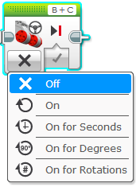

## Brake Options

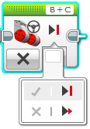

Turn Motor Off and Brake Motor

Turn Motor Off and Coast, No Brakes

# Move Tank – Menu

## On

This block should only be used inside a loop.

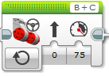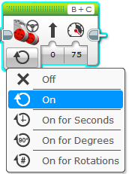

## Steering Option

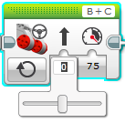

Drag to select your Steering.

Direction of Movement

## Power Option

Use either option.

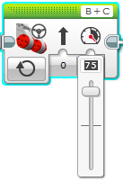

Type your Power.

Drag to select your Power.